1. Code

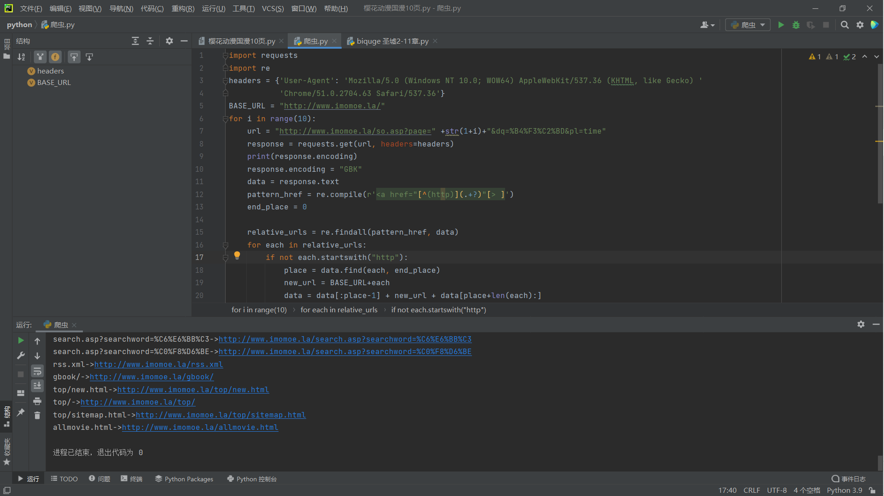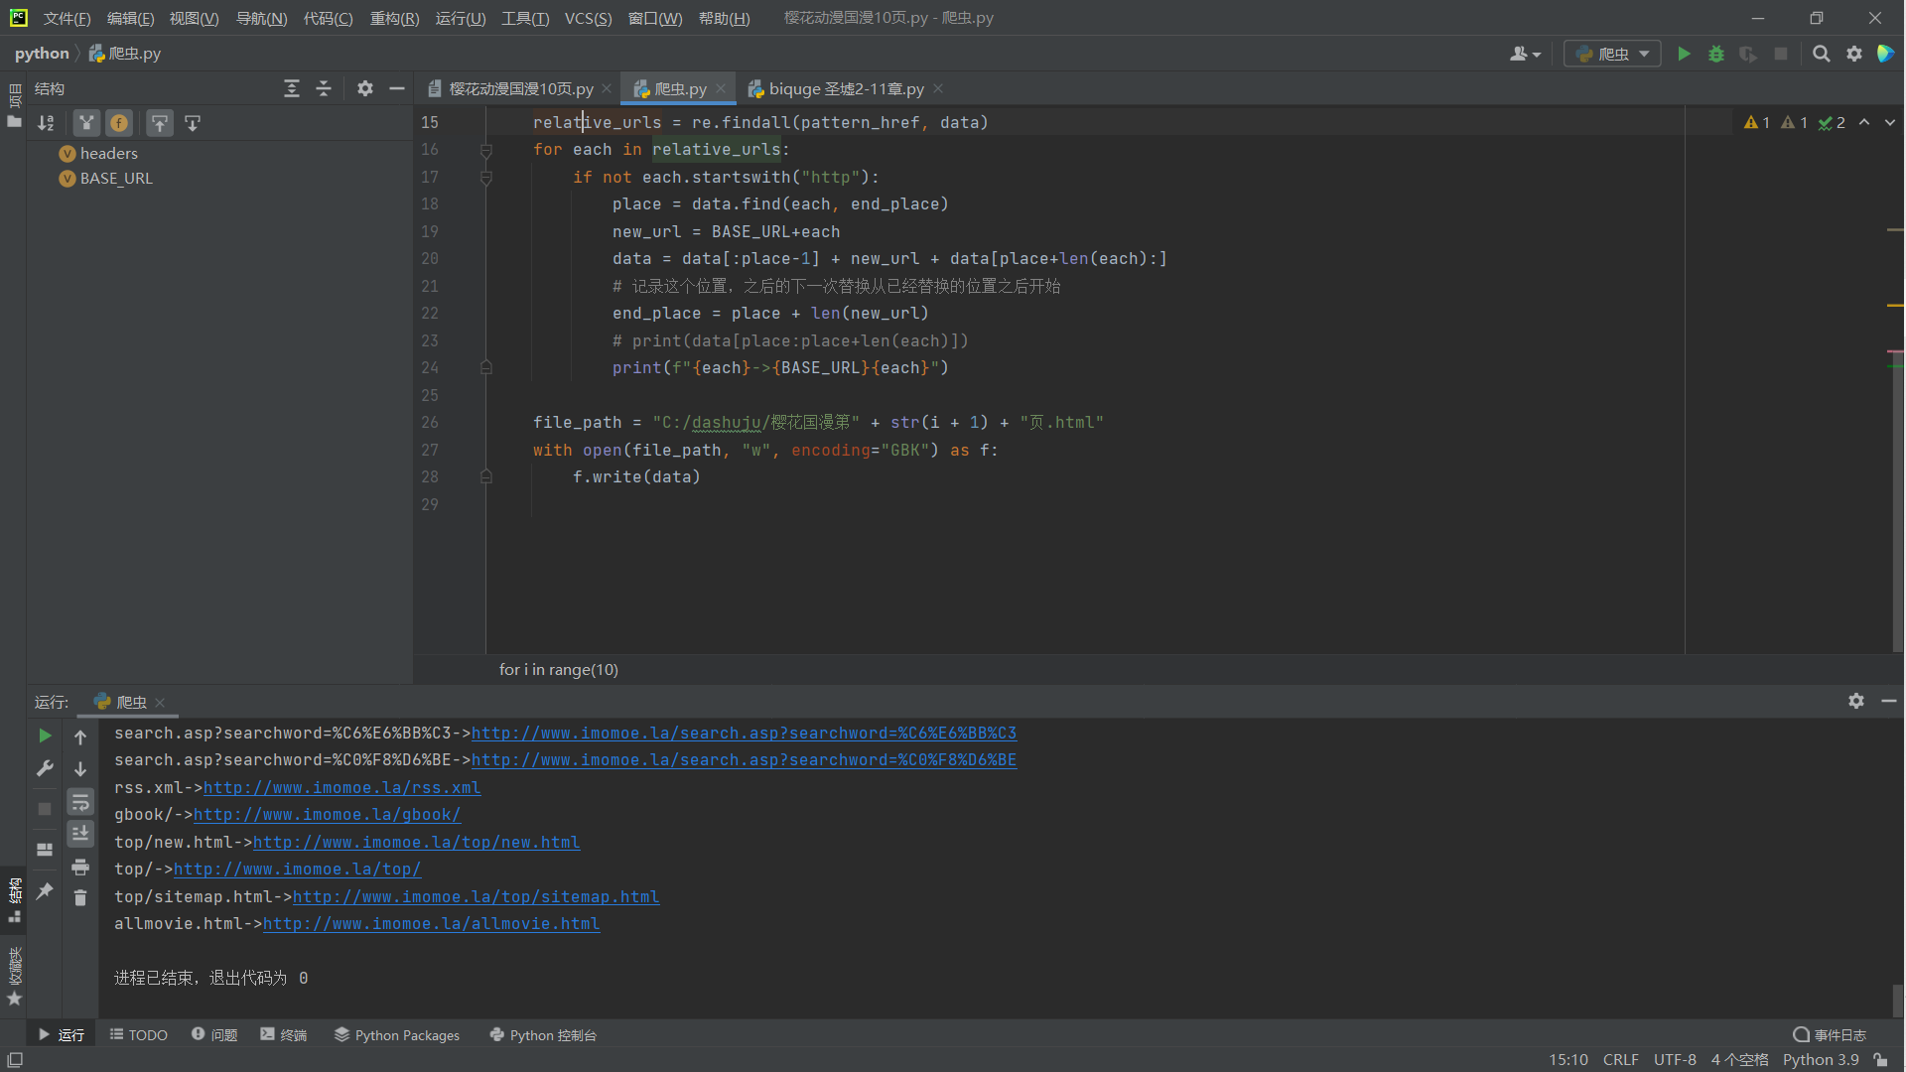

* 1. The for loop is used to crawl multiple novel pages, in this case two pages.





* 1. Because there are relative links in the crawled web page, you need to identify them and complete "http://www.imomoe.la/" to make it an absolute path
  2. file_path indicates the save address defined by the user.
  3. For some websites that need to be logged in, if you do not send a request from the browser, you will not get a response. So we need to customize the page request header, using a way to disguise as a browser to climb the page. Headers is the custom header in this figure.

1. Results show
   1. The crawl content portion of the store:

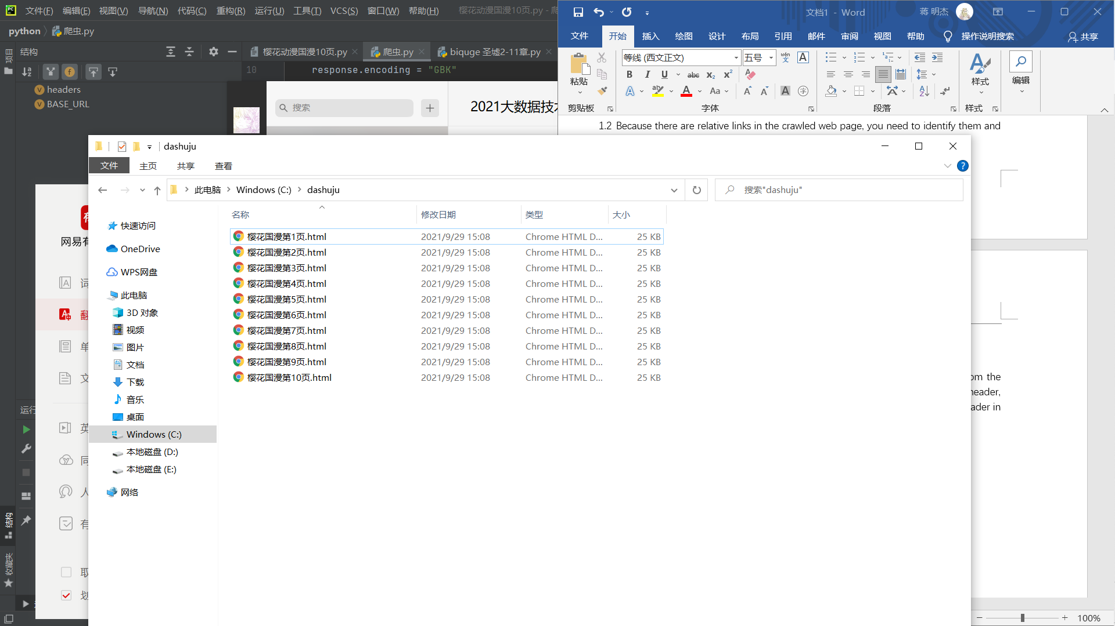

* 1. The crawlable page opens in Chrome:



* 1. The relative path of completion becomes an absolute path:



Relative path on the original web page



The relative path has been changed to an absolute path